@Override: Compile time check for a method to have been overridden properly

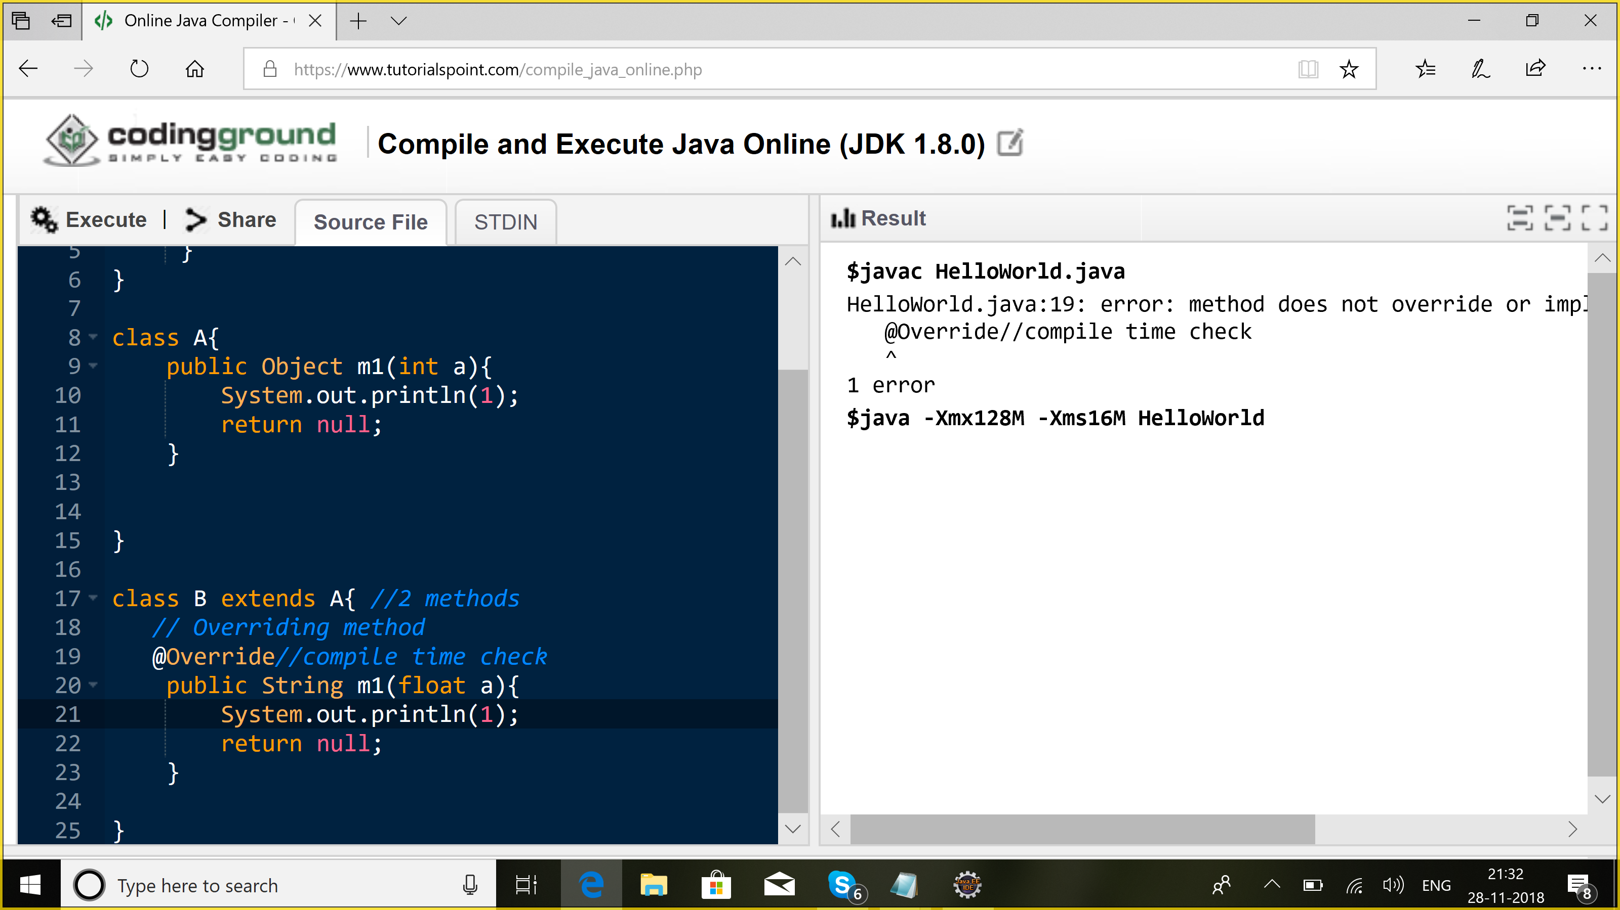

Overloading: arguments should be different

Overriding: arguments should be same but return type should be same/ covariant

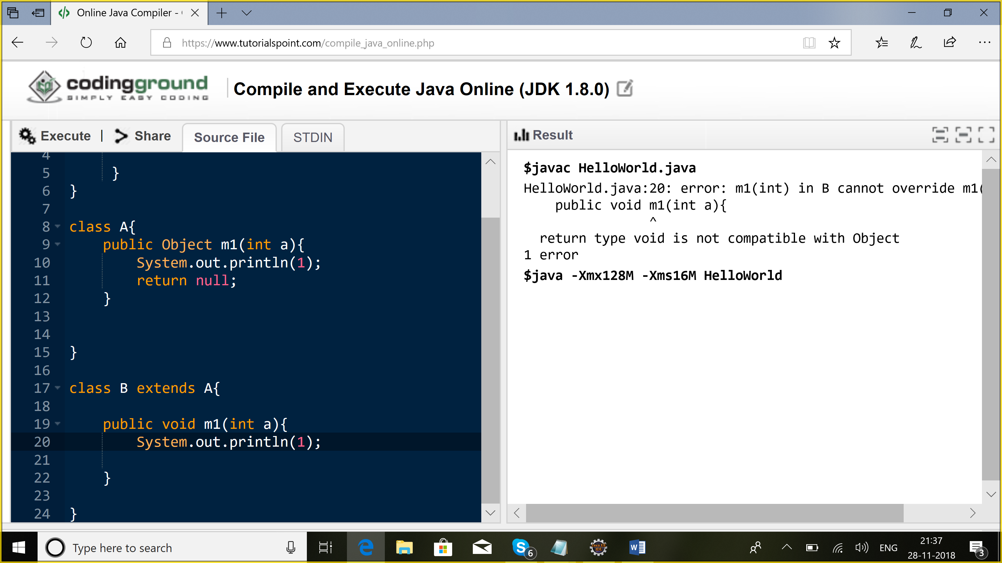

If it is not overloading & overriding => error

Abstraction:

Interfaces: contract | abstract class:

Default methods in interfaces

Methods: public & abstract

Properties: public, static, final

Access modifiers:

1. Public: all
2. Protected: package + child classes in different package
3. Default: package
4. Private: only in the present class

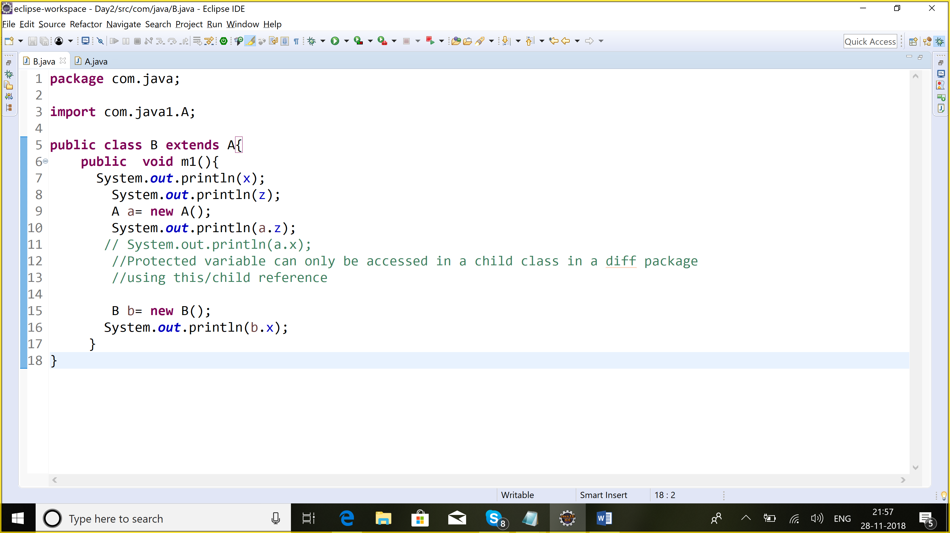

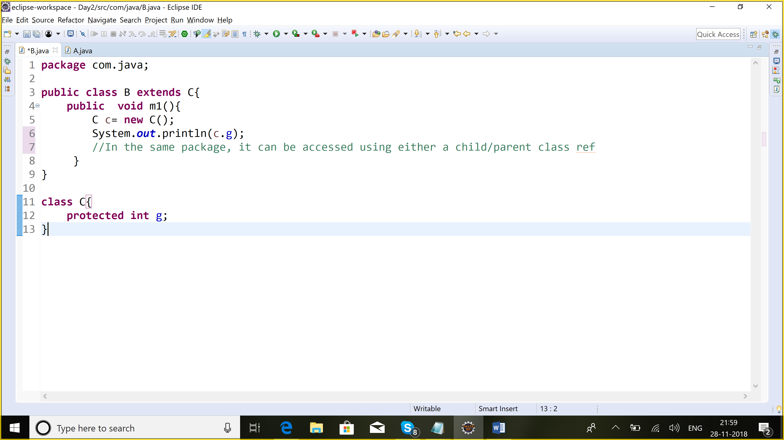

|  |  |  |  |  |
| --- | --- | --- | --- | --- |
|  | Protected | Default | private | Public |
| Same class | Y | Y | Y | Y |
| Same package diff class | Y | Y | N | Y |
| Diff package diff class | N | N | N | Y |
| Same package child class using this ref | Y | Y | N | Y |
| Same package child class using parent ref | Y | Y | N | Y |
| Diff package child class using this ref | Y | N | N | Y |
| Diff package child class using parent ref | N | N | N | Y |

**Variables:**

1. Local: These are not initialized by default.
2. Instance: These are initialized by default
3. Class /static: These ae initialized by default

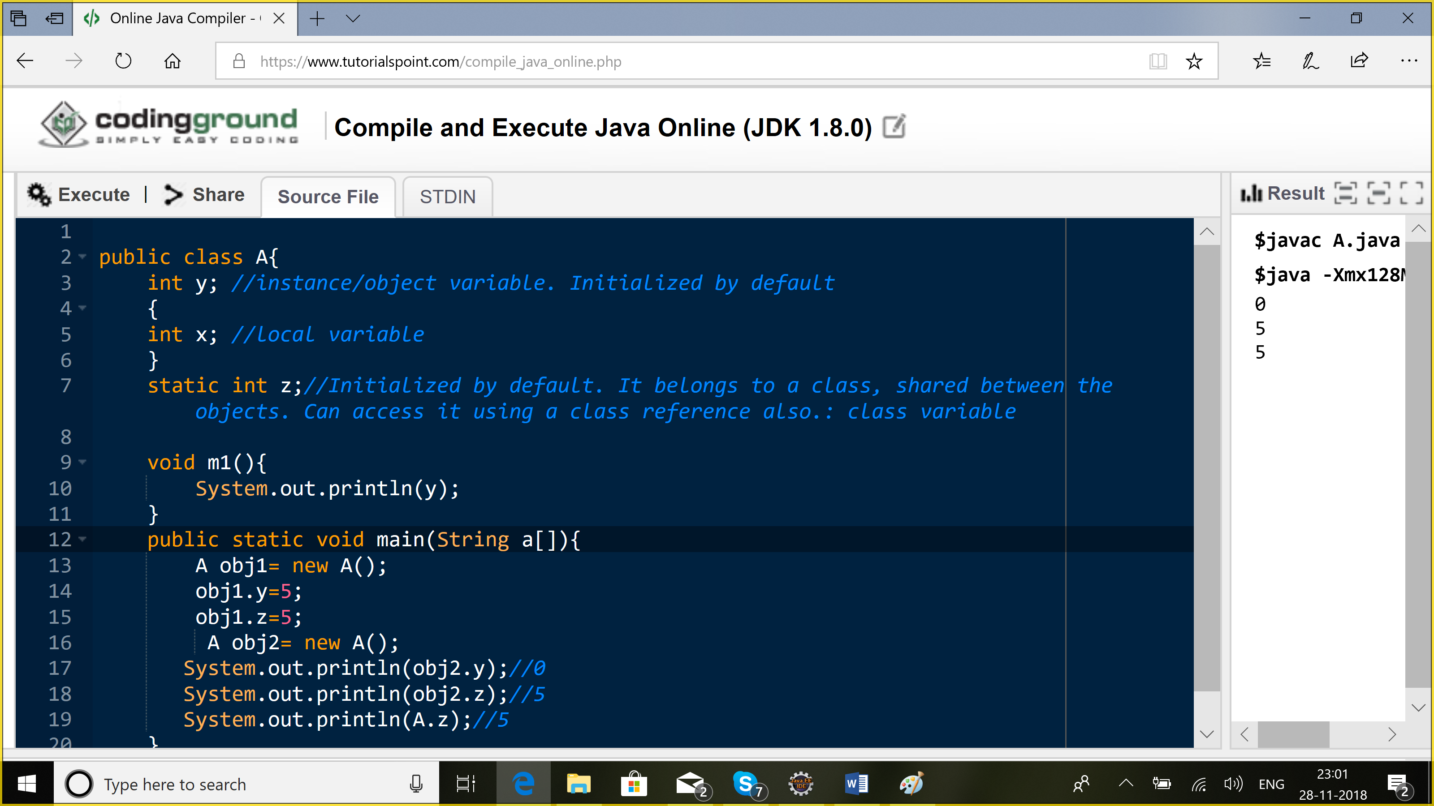

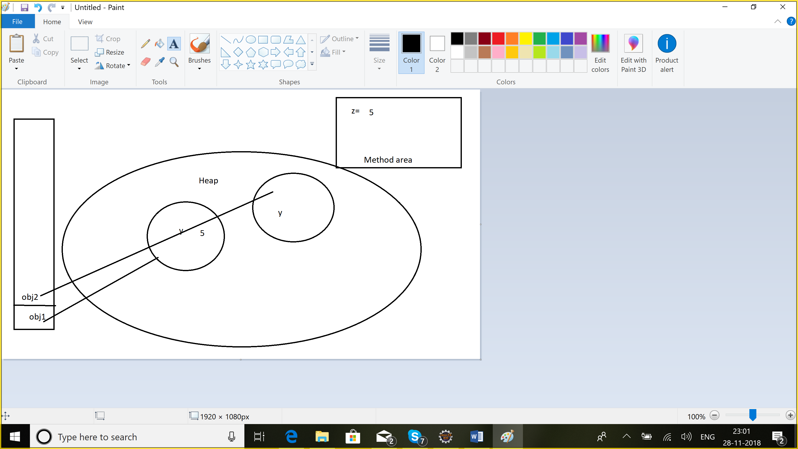

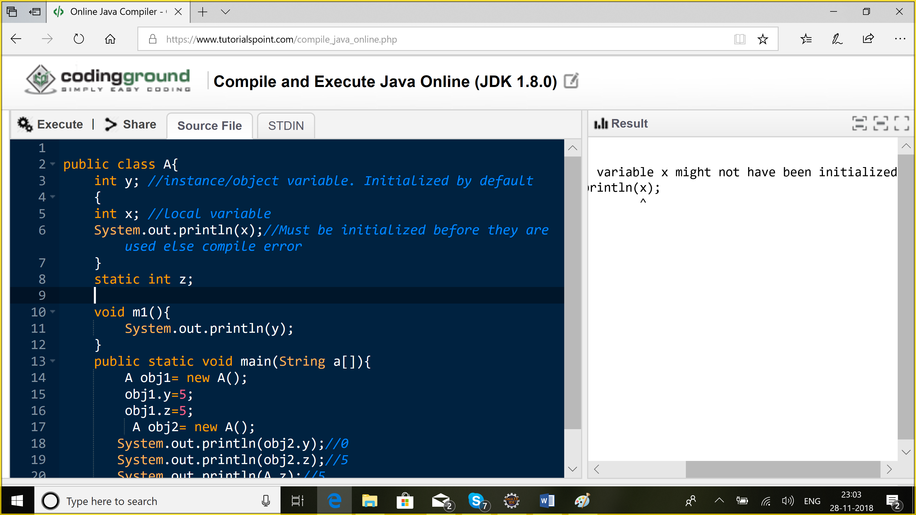

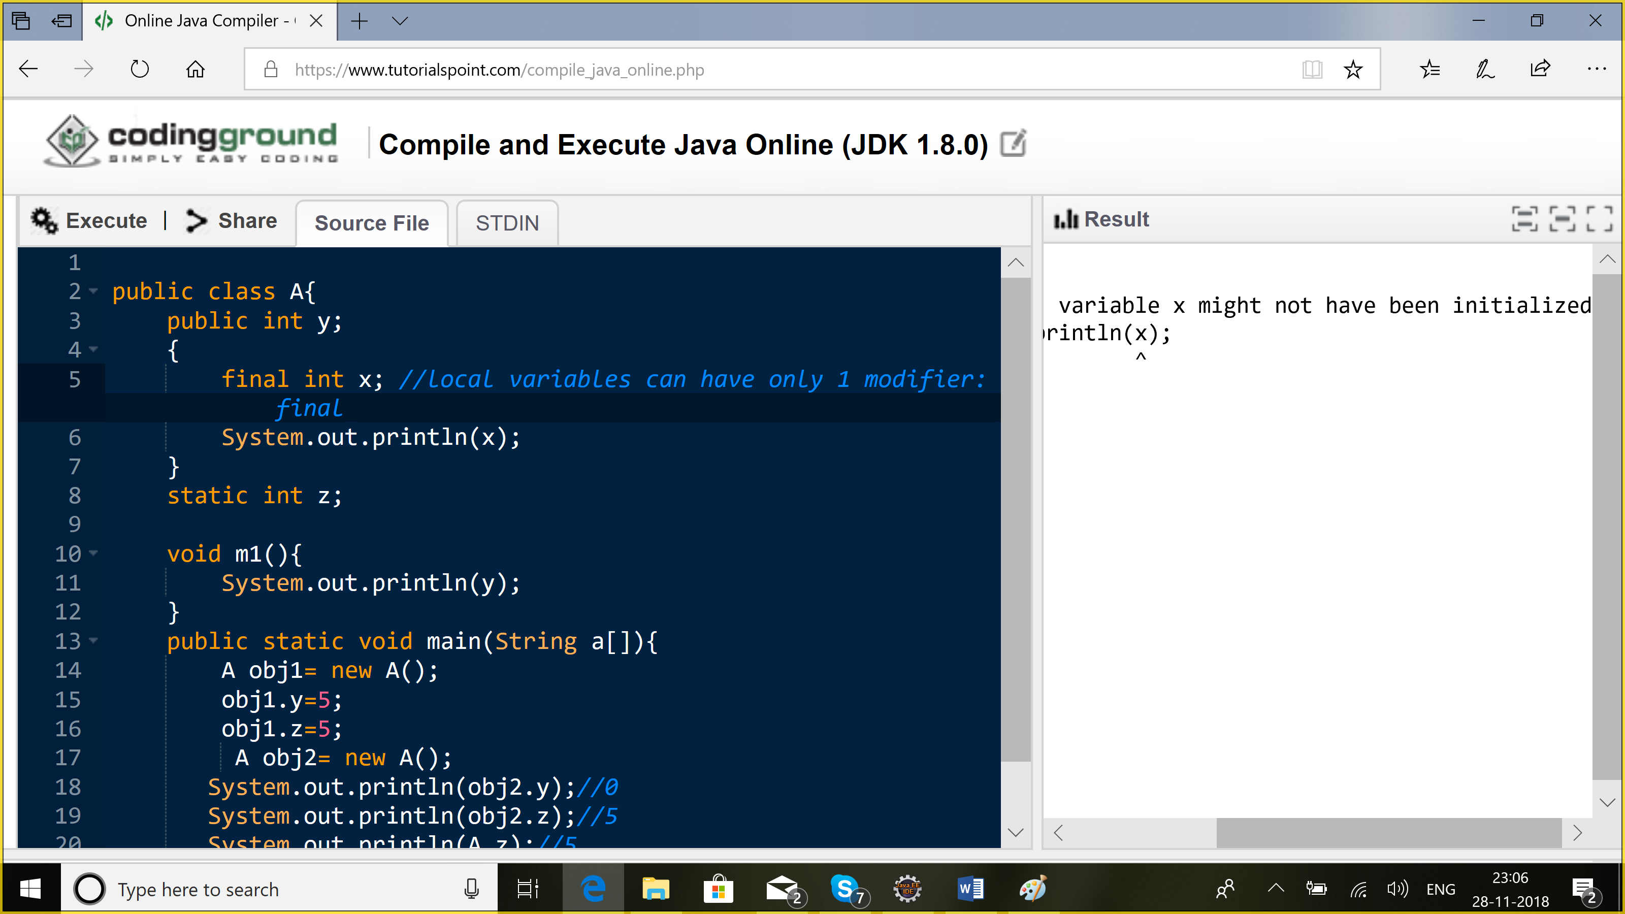

Modifiers:

1. **Static**: variable, method, block

**Static variable:** belongs to a class, can be accesses using a class reference. Initialized by default. This variable is shared among all the objects. Changes done by one object can be seen by the other.

Class Employee: numberOfEmployees;

**Static method:** Belongs to a class. I can directly call it using the class reference.

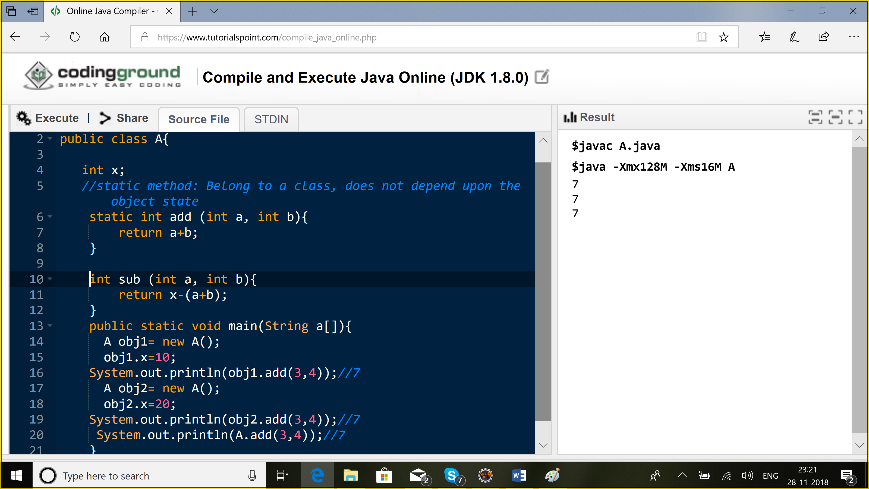

**Static method:** Cannot access non-static variables or methods

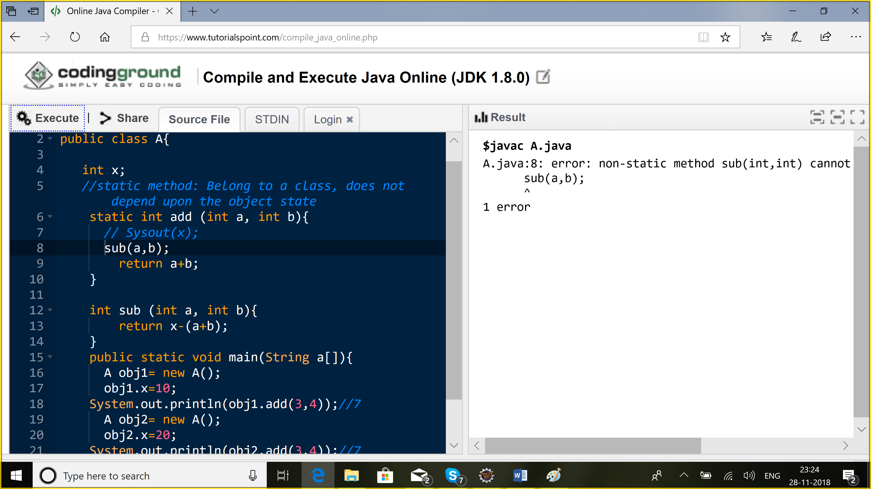

**Instance block:**

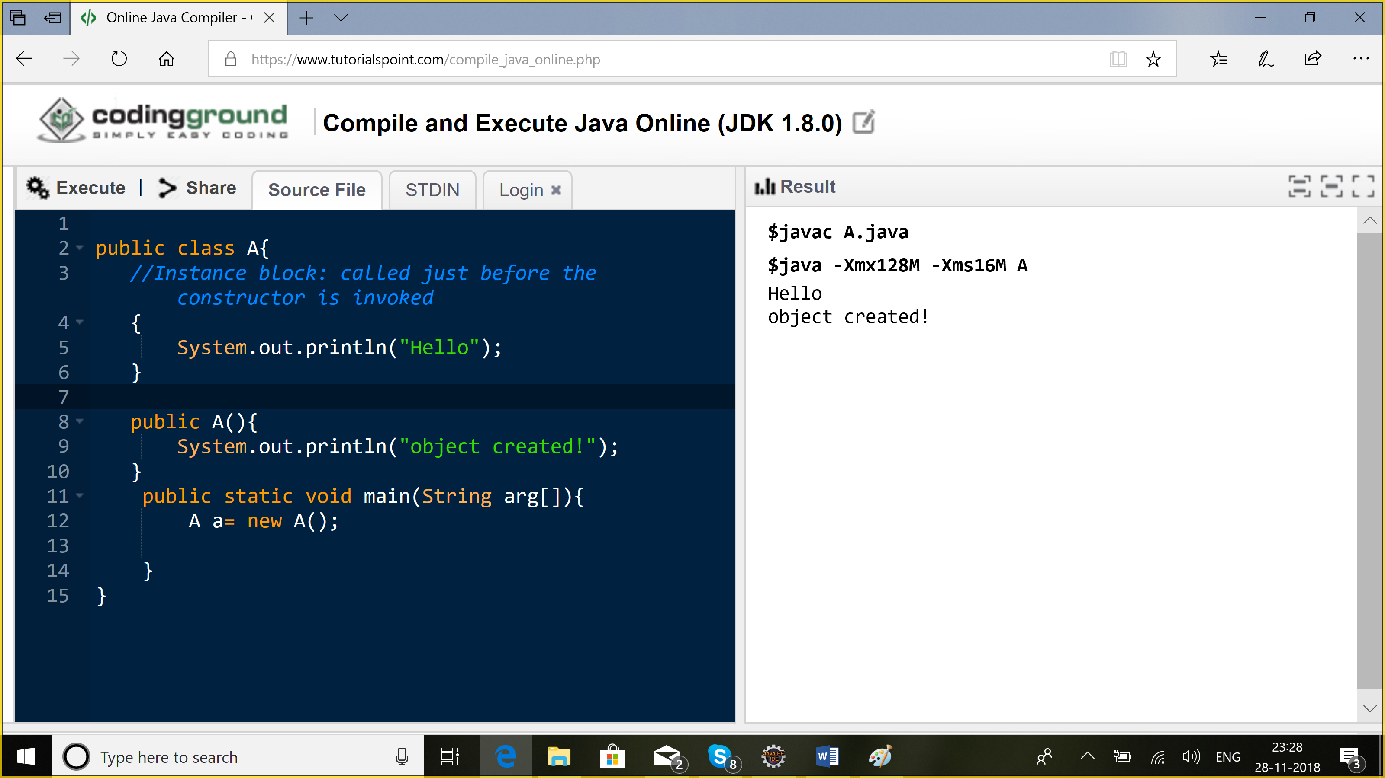

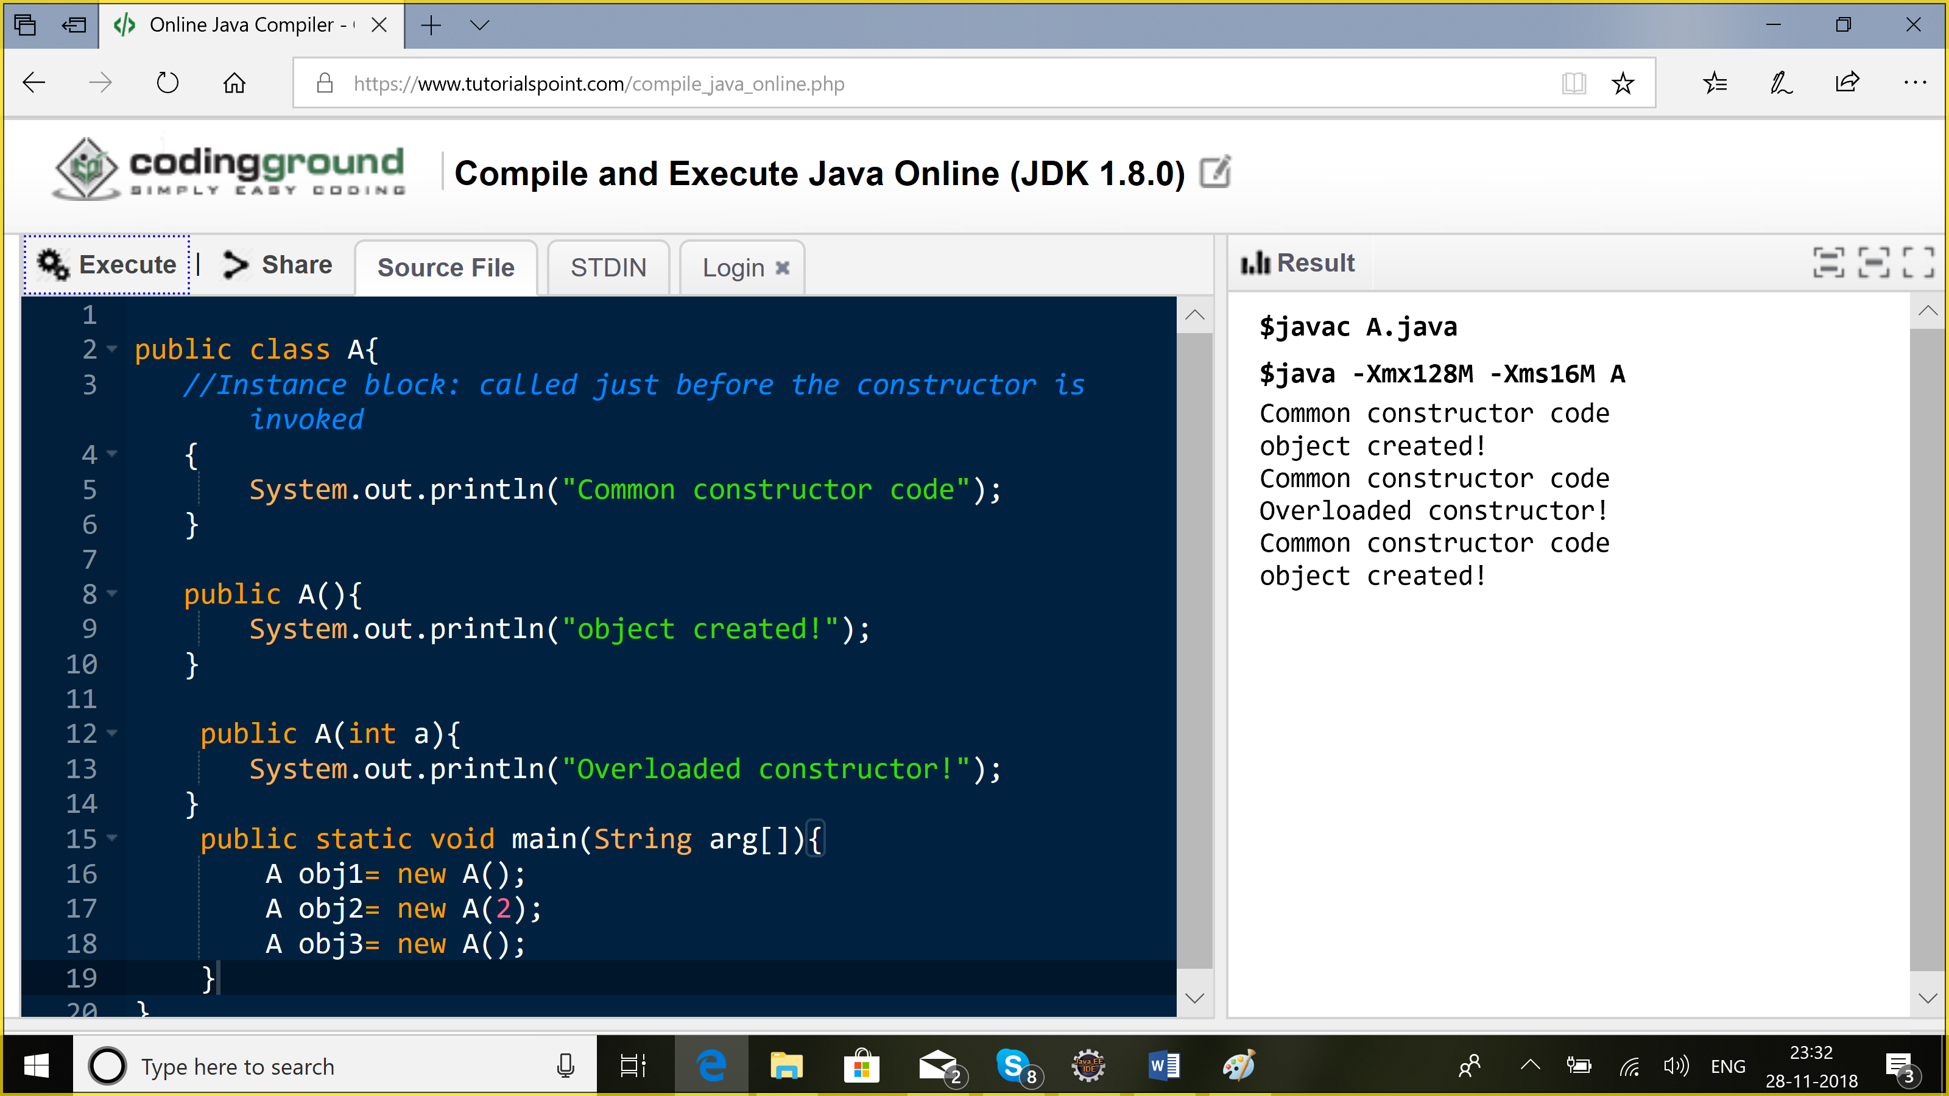

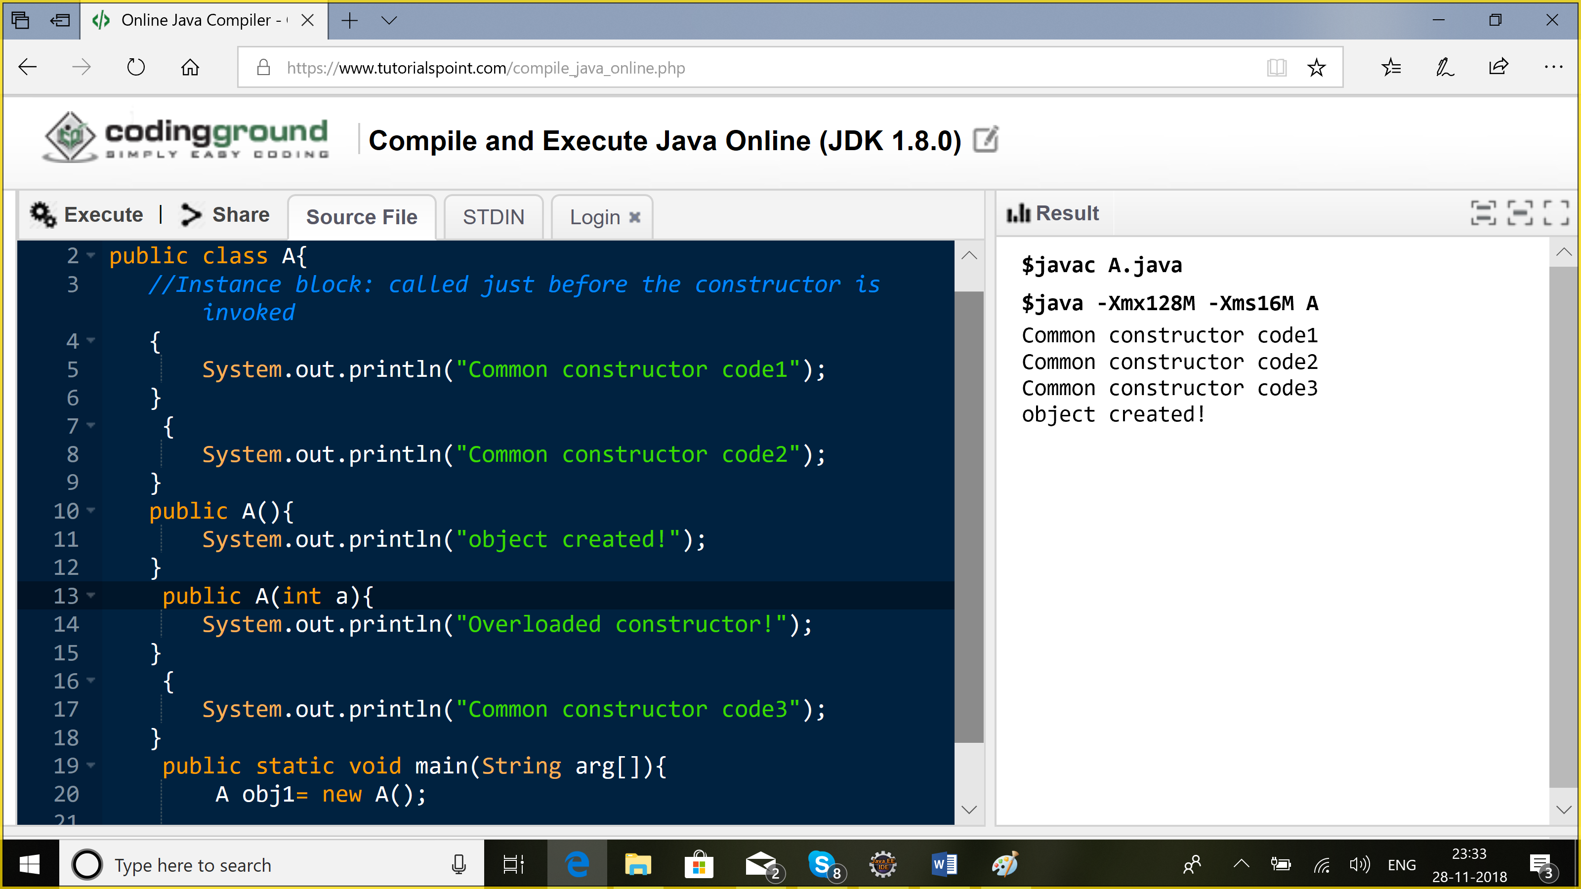

Static block:

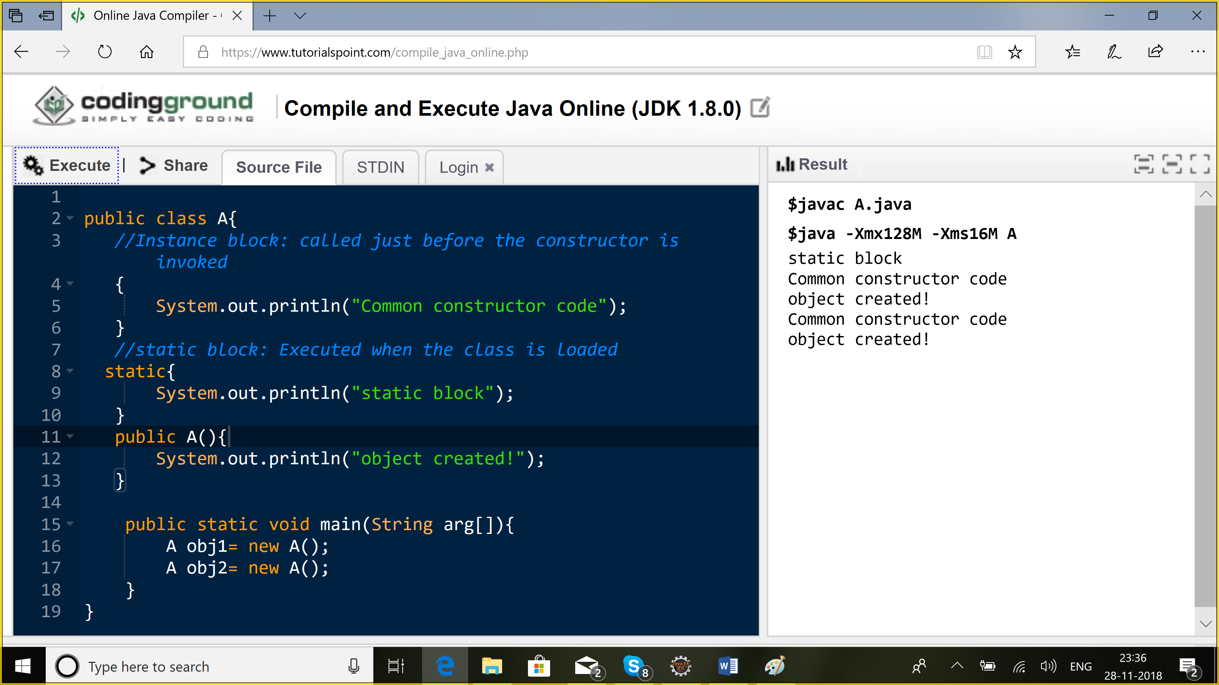

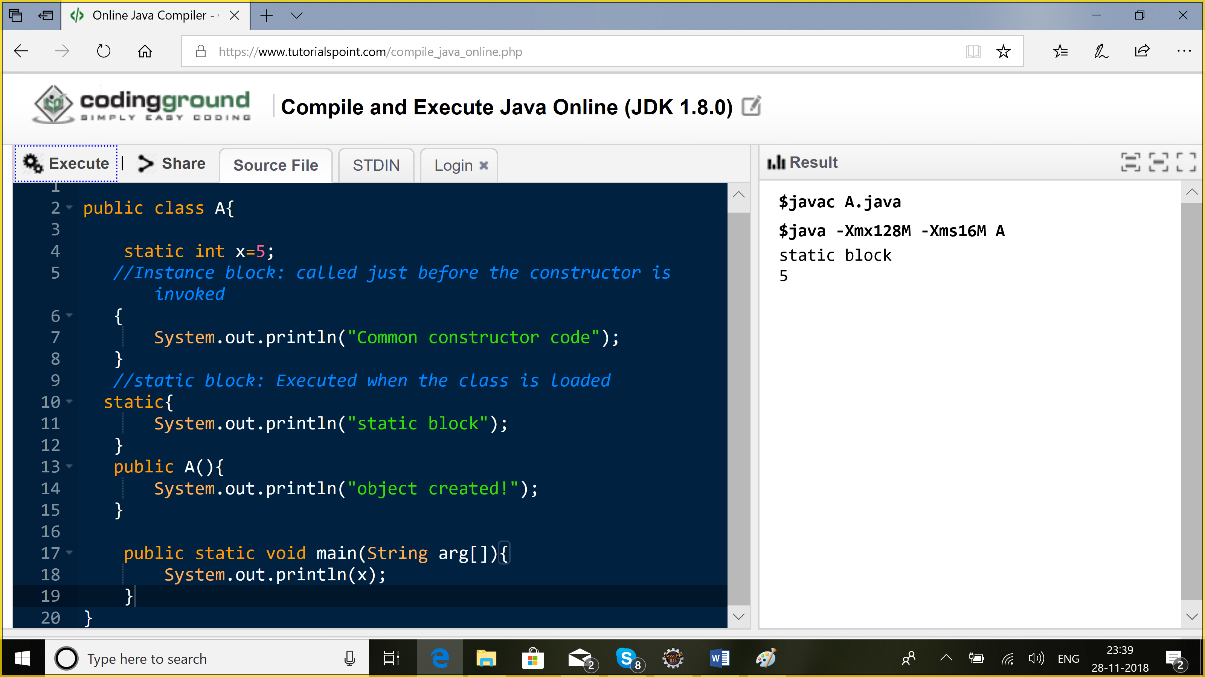

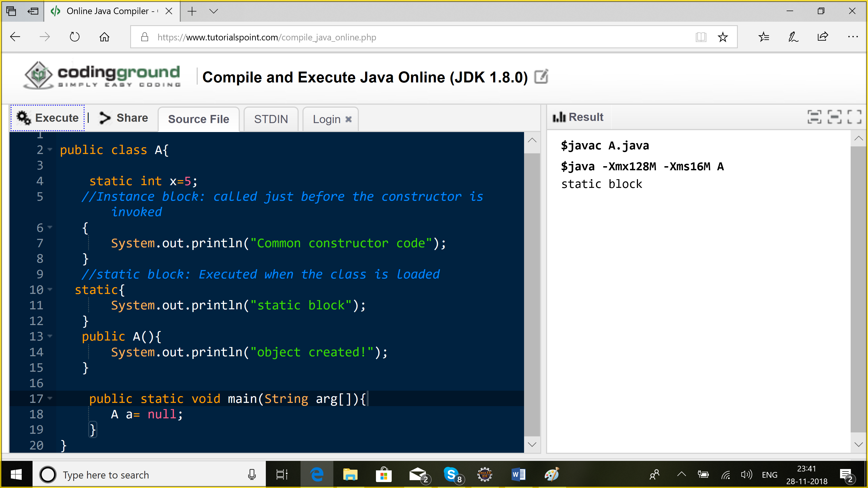

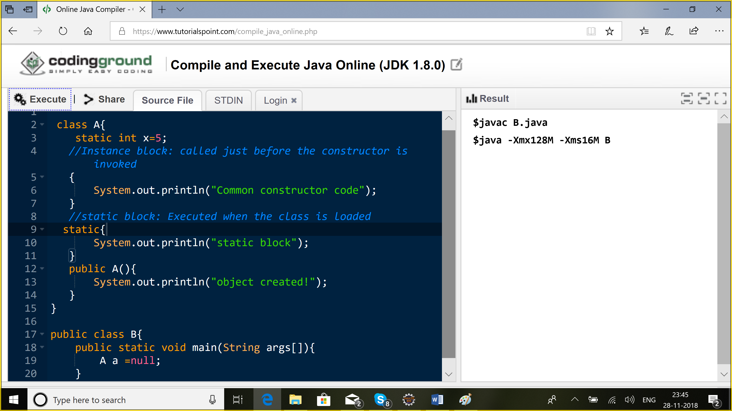

**ClassLoaders:**

Loading the class into ur jvm

1. Bootstrap classloader: rt.jar
2. Extension: will load class from ext folder
3. System/Application: will load classes in application/classpath

Java.lang: this package is imported by default

When I execute my appl, bootstrap will load rt.jar classes

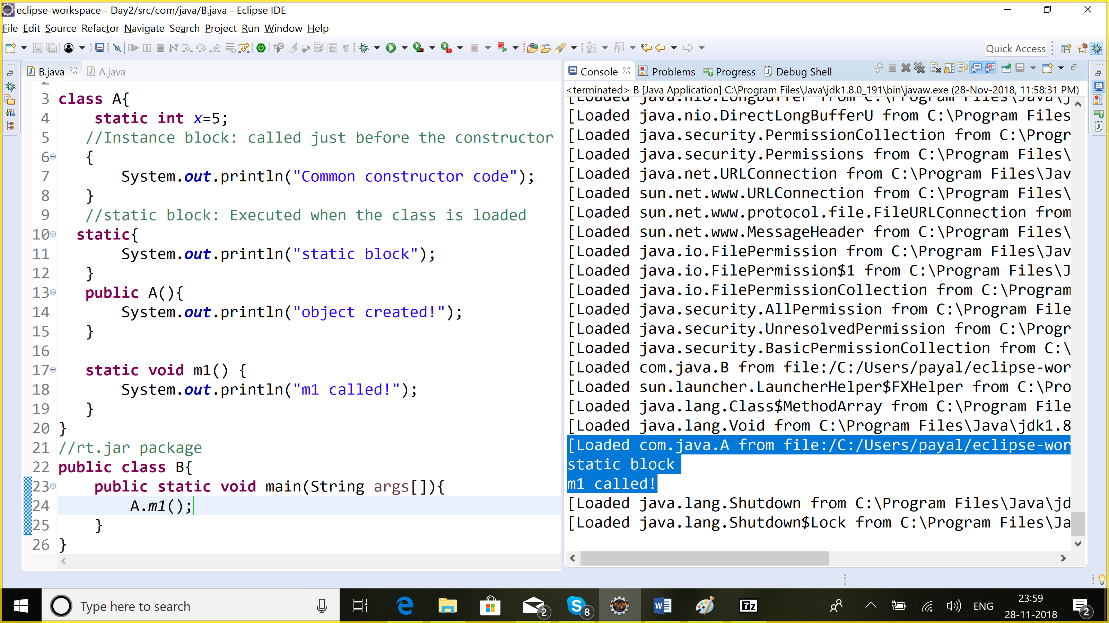

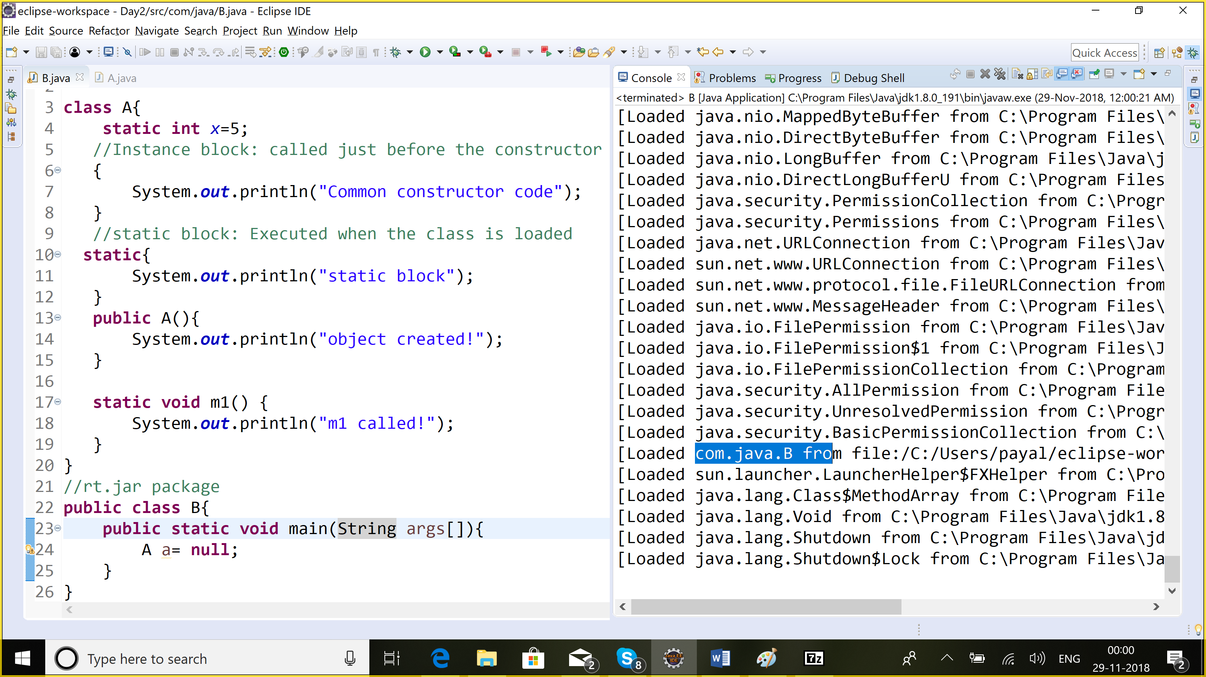

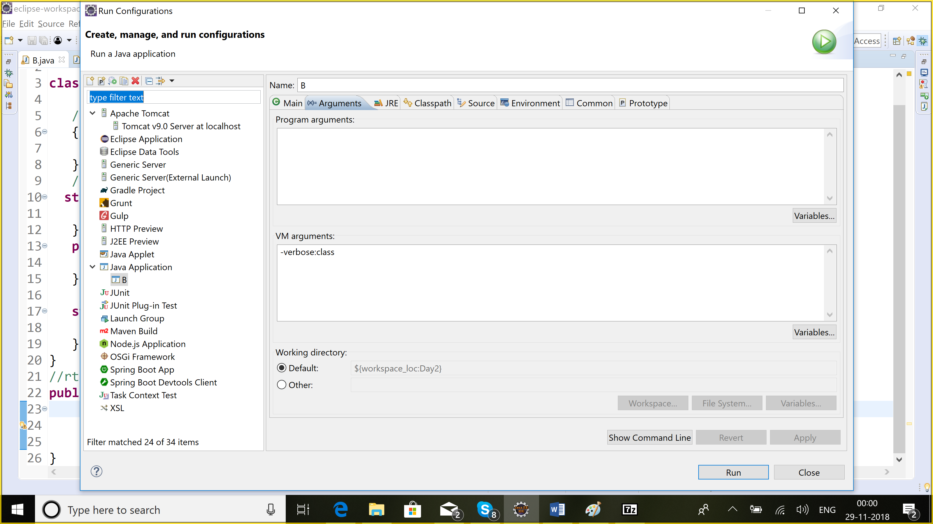

While loading the classes: delegating design pattern

1. Bootstrap classloader: rt.jar (not written in java)
2. Extension: ext
3. System/Application classloader

JournalDev

GeeksOfGeeks

Baeldung

Mykong

Q) How classloader works in java?

Q) static